WikiWalks – Architecture

# Purpose

This document describes the philosophy, decisions, constraints, justifications, significant elements, and any other overarching aspects of the system that shape the design and implementation of the project, such as WikiWalks’ dependency on Google Maps, and a reliable back-end server. It also sets out to describe the reason certain platforms were chosen for front- and back-end development.

# Architectural Goals & Philosophies

The WikiWalks project is being developed using the Unified Process, as is set out in the subject requirements. Extensive planning has been done at the beginning of the project so the team has a clear vision of what WikiWalks will be before development actually starts, and that when the development process reaches the implementation stage, the team will know exactly what needs to be done, and will be able to easily accommodate their implementation of features to be compatible with future features. The WikiWalks application will be designed with a focus on simplicity and usability for its users. This is important as a good user experience will encourage users to record paths, and because WikiWalks uses community-driven data, the more people who contribute path data, the better the database will be. Other key priorities for the app include a focus on maintainability, as WikiWalks hopes to be able to update the application with ease, and recoverability, as WikiWalks is reliant on a single database to store its data. If this database was damaged, the app would no longer work. Lesser, but still important architectural goals include: capacity, as many people could add data to the server or request it at any time, and data integrity as the data going to the server will need to be reliable and accurate for a good user experience. The app also needs to ensure proper security and privacy measures are taken, as the application will have access to user’s location, which needs to stay private.

# Assumptions & Dependencies

When designing the WikiWalks application, it has been assumed that users will have had experience using basic mobile apps and that they will know how to operate a mobile application. WikiWalks will be designed to work on GPS enabled Android devices running Android 4.1 (Jelly Bean) or higher, and assume that users will have access to an internet connection to download and upload map data from Google Maps and WikiWalks’ server. WikiWalks will be dependent on users having access to a device that meets these requirements. The application will also be dependent on Google Maps to provide the map.

For developing the back-end, WikiWalks is dependent on a reliable internet connection, and a server running Linux with Nginx and Flask to store, process, and backup path data.

# Architecturally Significant Requirements

Significant architectural requirements include:

* Data backups being done regularly without disrupting user access
* Paths being able to be added to and removed from the database
* Detection and rejection of bad paths (e.g. incorrect format, or being created in an impossible place)
* No less than 10 minutes of server downtime a week
* Combining the data of multiple path recordings to more clearly show the track
* The ability to update the application without affecting the servers
* The ability to update the servers without affecting the application
* The ability for the WikiWalks server to handle multiple users uploading and requesting data at the same time

# Decisions, Constraints, & Justifications

Decisions:

* The WikiWalks team is developing our application for Android 4.1 (Jelly Bean). This was chosen as applications developed to run on at least 4.1 are able to be run on 99.6% of Android devices.
* WikiWalks has chosen to use Google Maps to provide its mapping data and to show user location. This was done as the Google Maps API is widely used and well-documented. Google also provides $200 worth of credit each month, which means that its implementation will likely come at no financial cost to the team.
* WikiWalks has chosen to implement a way for users to remove or request removal of a path. This was done so that paths that go over private property or are dangerous can be removed.
* WikiWalks will implement a feature to allow users to add points of interest to paths they have been on so that other users are able to navigate more easily.
* The WikiWalks back-end will be developed using Python and the database where path data is stored will use SQLite. Python and SQL were chosen due to the WikiWalks team having had experience in both languages.
* The WikiWalks front-end will be developed using Java in Android Development Studio. This was selected due to WikiWalks having experience in developing programs in Java, as well as having experience using Android Development Studio.
* WikiWalks version control will use GitHub. GitHub was selected as it is widely used and reliable, and all team members of the WikiWalks app have had experience using GitHub.
* WikiWalks will be able to run in the background and should use as little power as possible to prevent draining the user’s battery. This was decided as, if the application drains power quickly, users will be less inclined to use it.
* Each track will be a different colour depending on how often it’s walked by users. This decision was made as users may want to quickly see path popularity, and take paths that are travelled more often.
* WikiWalks will implement a feature that will allow users to choose a specific route in a cluster of related paths.
* WikiWalks will implement a group walk feature so that multiple users can meet up and walk a track together.

Constraints:

* WikiWalks has less than a year to be completed. Due to this time constraint, the development team needs to stay on schedule and not fall behind.
* WikiWalks is constrained by some Google Maps features costing money to use. To work around this, our team is developing the application to interact with Google Maps as infrequently as possible.

# Architectural Mechanisms

## Usability

WikiWalks must have a high level of usability for users of all skill levels. WikiWalks will also be designed so that it is able to be run in the background of phones without using a significant amount of power, allowing users to take longer walks.

## Relational Databases

WikiWalks contains a relational database to store paths, reviews, points of interest and images. This is to increase usability and performance of the system as it will allow paths to be shared and users to review tracks they take, further contributing to the crowdsourced data.

## Backups

Weekly backups of the WikiWalks database will be done. This to increase data integrity and recoverability. If the WikiWalks database is ever corrupted or has some other issue causing it to go down, the app would essentially become useless, as it relies on the database to pull and upload paths. The backups aim to mitigate this by allowing quick recovery.

## Network Connection

Networks are used to allow users to submit data to the WikiWalks servers, request the paths for an area, and get maps from Google Maps. A connection must be made at some point after a new walk is completed to allow users to upload their path data.

## Removing Paths

The WikiWalks server will implement the ability to remove paths by the original uploader and by the administrators. This is to help increase data accuracy as paths may no longer be accessible or may become dangerous to take.

## Security

All incoming data to the WikiWalks servers will need to be verified. This is done to increase reliability of information. WikiWalks will check that points are not in inaccessible areas, e.g. lakes, and that the data appears to have been legitimately collected during a walk instead of something like a drive.

Additionally, as little user data as possible will be collected, and what is collected will be anonymised, meaning it’s more difficult to track users in the case of a data breach on the WikiWalks servers.

# Key Abstractions

|  |  |
| --- | --- |
| Key Abstraction | Description |
| User | Someone who uses the WikiWalks application |
| Track | A section of path that can make up a track, often an alternate route |
| Path | A combination of multiple tracks combined together, the complete route that a user takes on a walk |
| Front-end | The WikiWalks Android application |
| Back-end | The WikiWalks server |
| GPS | Global Positioning System, a way of finding a user's exact location |
| Google Maps | A mapping service and API provided by Google |

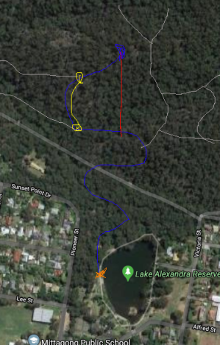Key:

* Blue line is the route a user took to get to a destination
* The yellow line is an alternate route on the path
* The grey lines are other available routes

# Layers or Architectural Framework

WikiWalks is going to use a four-tier architecture that contains:

1. A presentation tier. This is the part of the WikiWalks application that the users see and interact with. It contains data stored on the phone itself such as a cache of the paths in an area. This tier interacts with the application logic tier, and also pulls maps from Google Maps.
2. An application logic tier. This is where processes for the WikiWalks application take place, such as recording paths or creating points of interests. The application logic tier interacts with the presentation tier and sends data to the data processing tier.
3. The data processing tier receives and validates data sent via the application, and aggregates it with data stored in the storage tier to create clearer tracks. This data is then uploaded to the storage tier. It also pulls and responds with data from the storage tier when requested.
4. The storage tier contains all paths and points of interest in a database. This tier provides data for the data processing tier.

# Architectural Views

## Logical View – Class Diagram

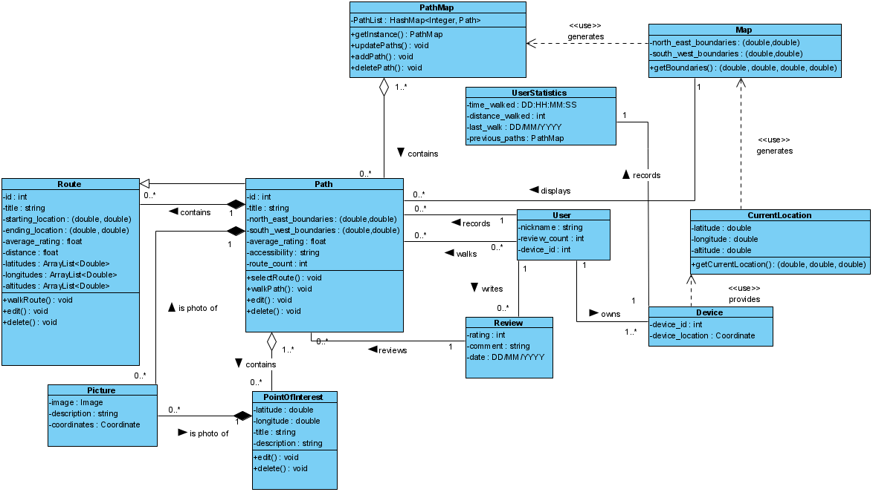

## Process View – Sequence Diagram

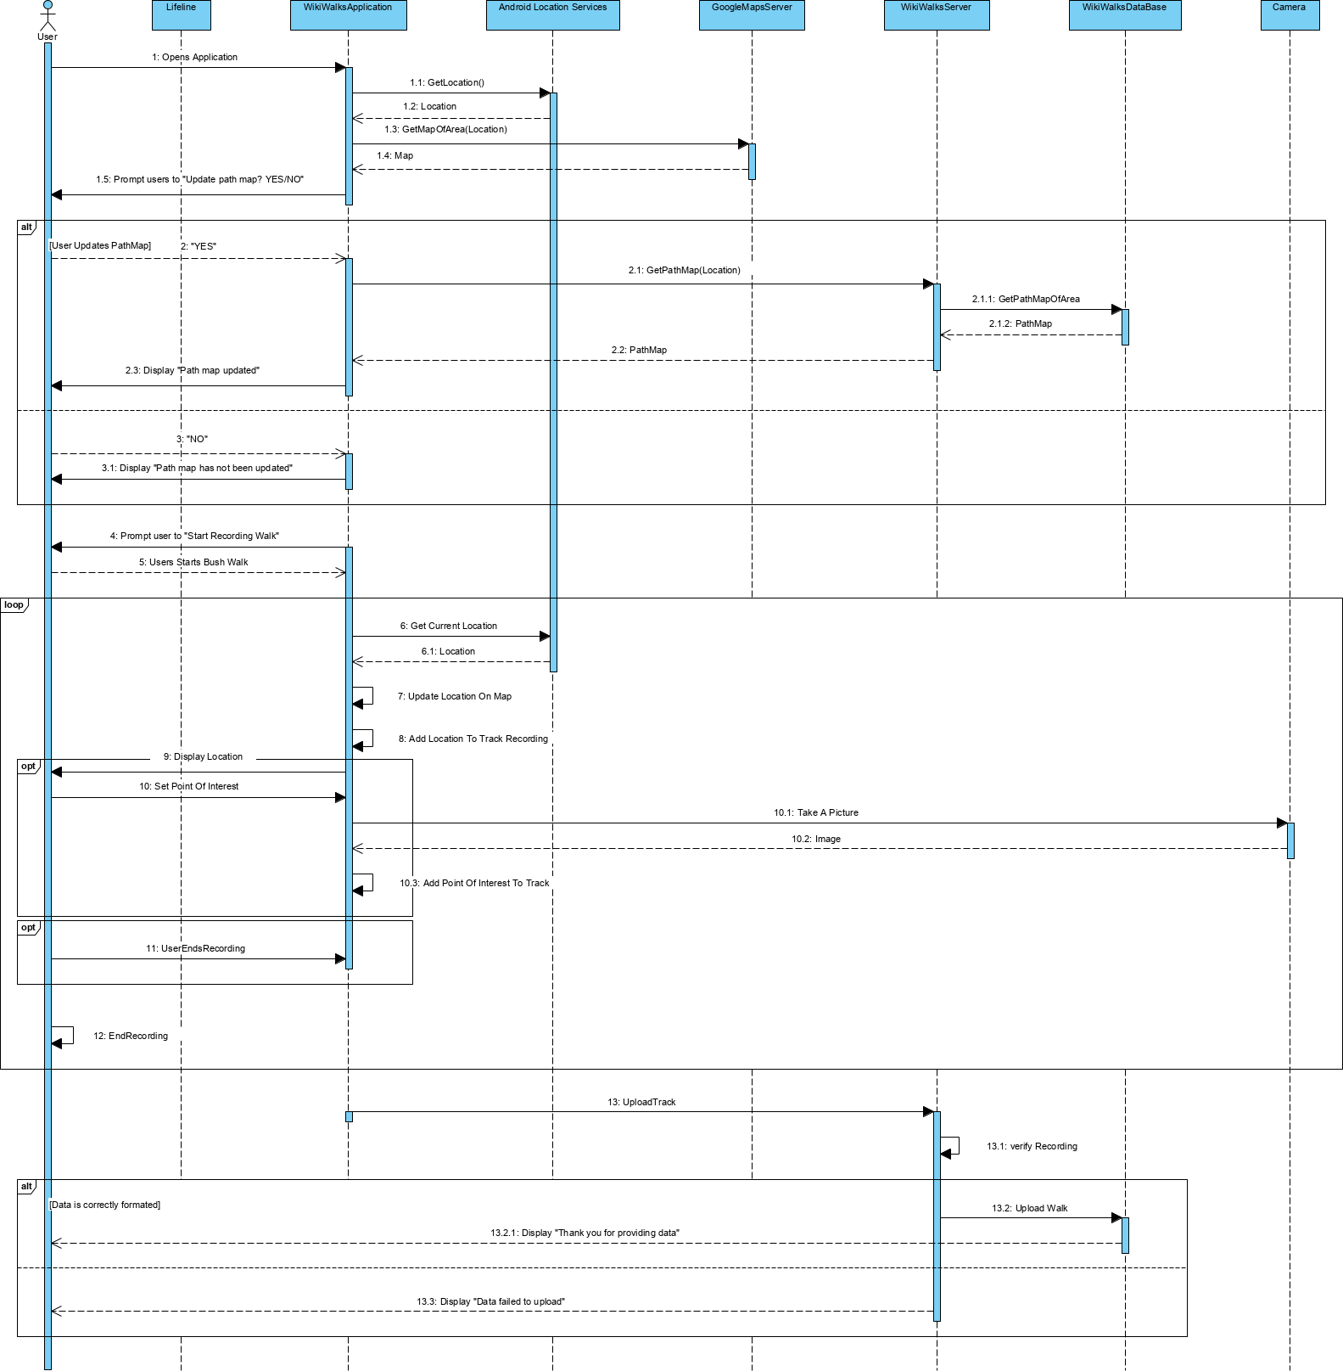

## Development View – Component Diagram

## Physical View – Deployment Diagram

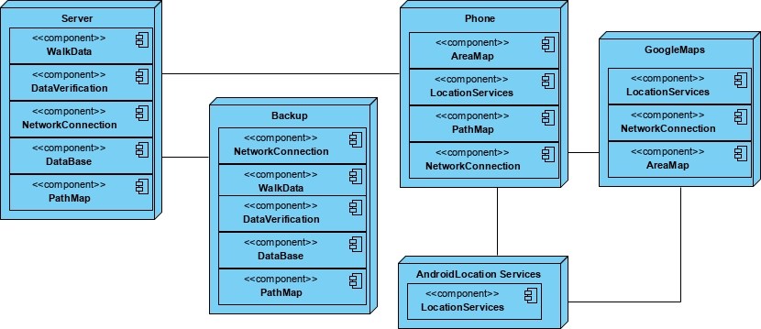

## Scenarios – Use Case

